HP-MOS European Partnership Project 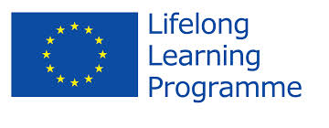
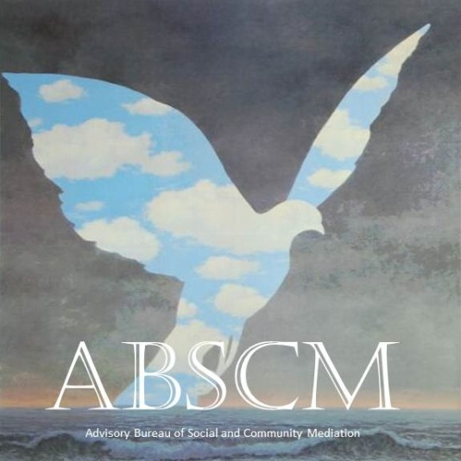
Name of Project: ADVISORY BUREAU FOR SOCIAL AND COMMUNITY MEDIATION (ABSCM) (2012-2014)
The Project Social and Community Mediation- involves an Advisory Bureau for Social and Community Mediation (ABSCM), which is inscribed in a multidisciplinary interest and participation from local and International partners. The partnership consolidates knowledge (theoretical and operative) in the field of mediation from different countries: UK, Italy, France, Switzerland, Germany, Spain and Portugal. It integrates Universities, Associations, Training Institutes, and staff of Professional/Academics. This factor enhances a variety of target audiences in terms of training, research and intervention, which is an asset for the Advisory Bureau for Social and Community Mediation project implementation.
HP-MOS EUROPEAN PARTNERS INVOLVED:
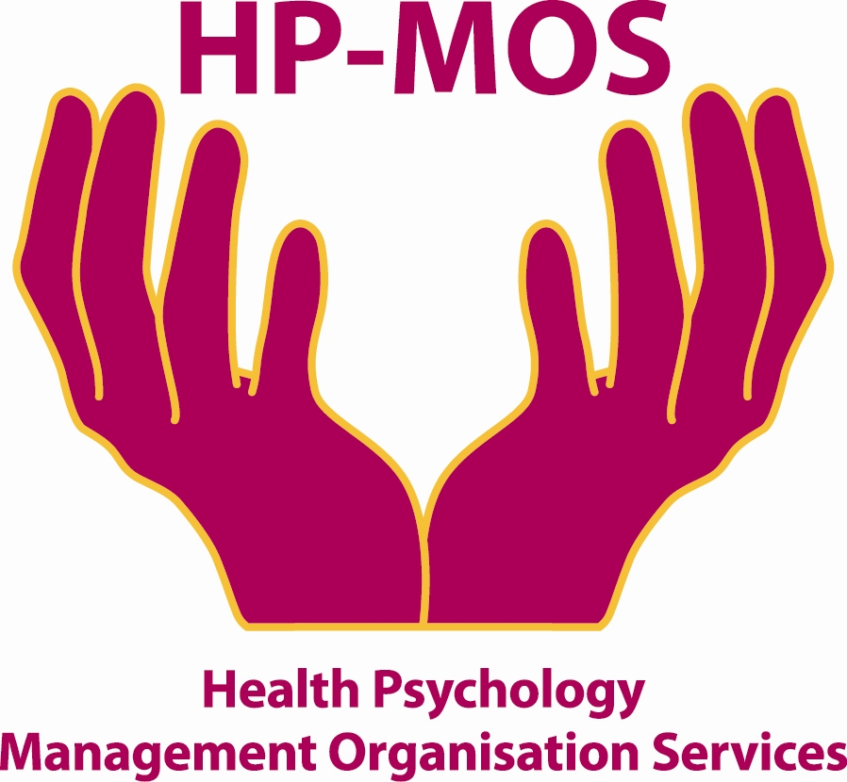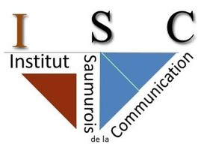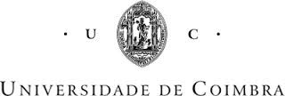
UK FRANCE GERMANY ITALY PORTUGAL SPAIN PORTUGAL SWITZERLAND
(SOLTAR OS SENTIDOS) (UNIVERSITY OF COIMBRA)

FOR MORE INFORMATION, PLEASE CONTACT: MERCY MACLEAN
E-MAIL: enquiries@hp-mos.org.uk
The project has been funded with support from the European Commission. This report reflects the views only of the author, and the Commission cannot be held responsible for any use which may be made of the information contained therein.
"ADVISORY BUREAU FOR SOCIAL AND COMMUNITY MEDIATION (ABSCM) "-

Project agreement No: 2012-1-PT-GRU06-12164

