HP-MOS European Partnership Project (2014-2016)

Title of Project: ALTERNATIVE TRACKS - integrated approach to minor offenders and their families.

HP-MOS and its 5 European partners from Italy, Romania, Bulgaria, Portugal and Greece are engaged in a European partnership project: ALTERNATIVE TRACKS - integrated approach to minor offenders and their families.

The project “ALTERNATIVE TRACKS - integrated approach to minors offenders and their families" (Alternative tracks) is to answer two tangible and emerging needs in EU:
a) the specific needs of the minors in the juvenile justice system, focused on the protection in relation to its capacity and future potential.
b) at the overall level, to create a positive impact of alternatives to imprisonment, for minors offenders, their victims and their parents, considering the environmental, personal and social perspectives.

Objectives of the Project: The overall objective of the project is to engage in mapping and scoping of good practices, developing innovative approaches to projects and services alternative to detention of minor offenders and their families and to build a Vademecum, which includes:
- socio-educational services designed to promote overall wellbeing of the deviant child, encouraging self-expression, respect for the dignity and autonomy, promote recovery and social education of minors subjected to judicial penalties, reduce the risk of possible aggravations for precautionary measures and / or relapse following the resignation of preventing juvenile delinquency;
- pathways to motivational orientation and individualised social-work aimed at educational law;
- restorative justice aimed at the empowerment of the offenders and the expression of the suffering of victims;
- involvement of the families of the offenders in programs of re-education, re-habilitation and re-integration with a work-based tangible approach, such as a cluster of competences, supported by a variety of materials such as an open webplatform, handbooks and tool-kits and videos recording, in English and also in the participating countries languages.
HP-MOS EUROPEAN PARTNERS INVOLVED:
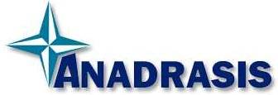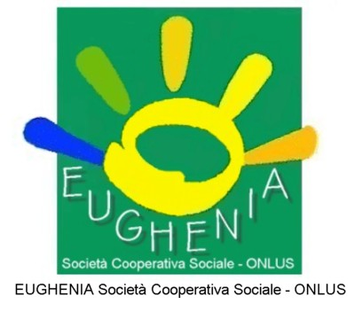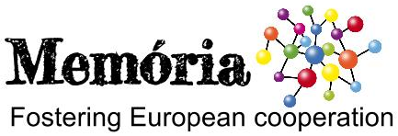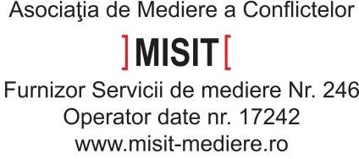
UK BULGARIA GREECE ITALY PORTUGAL ROMANIA

FOR MORE INFORMATION, PLEASE CONTACT: MERCY MACLEAN.
E-MAIL: enquiries@hp-mos.org.uk.The project has been funded with support from the European Commission. This report reflects the views only of the author, and the Commission cannot be held responsible for any use which may be made of the information contained therein. ALTERNATIVE TRACKS - integrated approach to minor offenders and their families

