HP-MOS European Partnership Project
Name of Project: Developing Effective Learner Training Across Europe
(D.E.L.T.A.-Europe) (2011-2013)

HP - MOS and its 4 European partners are engaged in GRUNDTVIG - LIFELONG LEARNING PROGRAMME to develop a manual in the form of a “book" of best practices for TRAINERS working with Adult Learners as a pathway for EFFECTIVE TRAINING.

- The summary of this partnership project is to develop quality in effective learner training across Europe through learning about different teaching/learner methods used by all partners, best practices and innovation through workshops and conferences.

Concrete Objectives of the Partnership Project:
- To implement opportunities for teachers/trainers to access quality information and maintenance of their skills in lifelong learning;
- To help provide TRAINERS with a pathway of completing AN EFFECTIVE TRAINING;
- To analyse the way TRAINING determine the quality of Continuing Education for Teachers/Adult learners in Europe;
- To facilitate EUROPEAN FRAMEWORK of quality in Training;
- To provide Innovative ways of training to trainers within adult education in Europe;
- To provide an evaluation of quality for the trainer/learner experience;
- To develop and analyse the way adult learners are trained;
- To address strategies involved in cooperative learning techniques and active learning methodologies.
HP-MOS EUROPEAN PARTNERS INVOLVED:
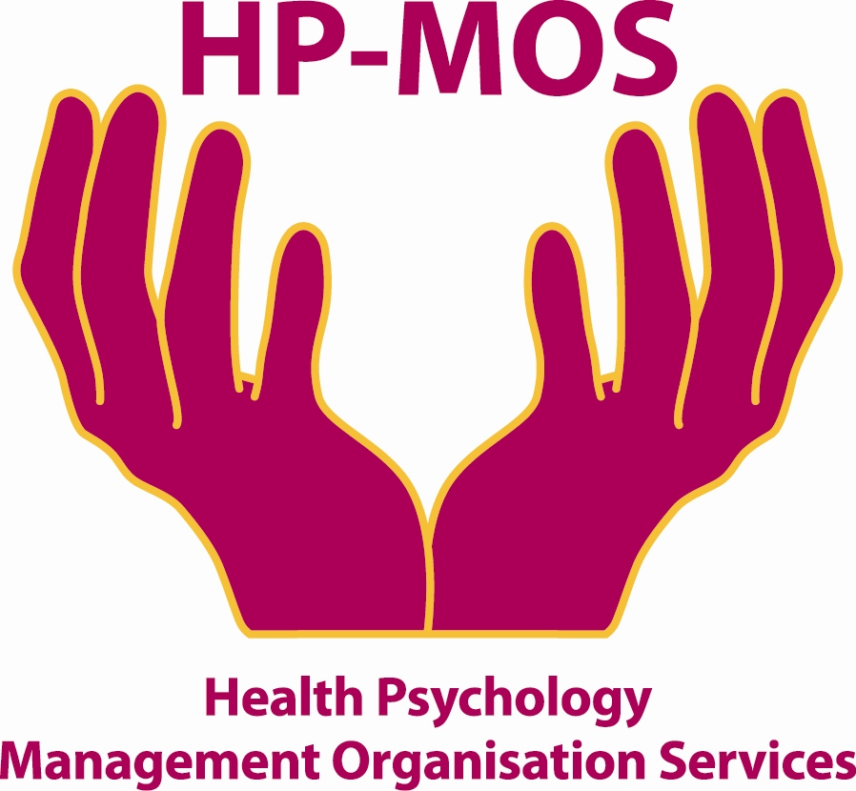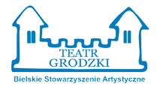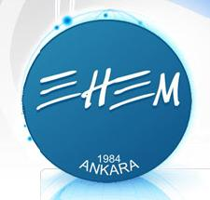
UK GERMANY POLAND SPAIN TURKEY

FOR MORE INFORMATION, PLEASE CONTACT: MERCY MACLEAN.
E-MAIL: enquiries@hp-mos.org.uk
The project has been funded with support from the European Commission. This report reflects the views only of the author, and the Commission cannot be held responsible for any use which may be made of the information contained therein. Developing Effective Learner Training Across Europe (D.E.L.T.A.-Europe)
Project Agreement No: 2011-1-GB2-GRU06-05303 1

