HP-MOS European Partnership Project 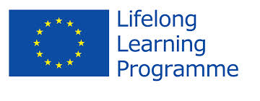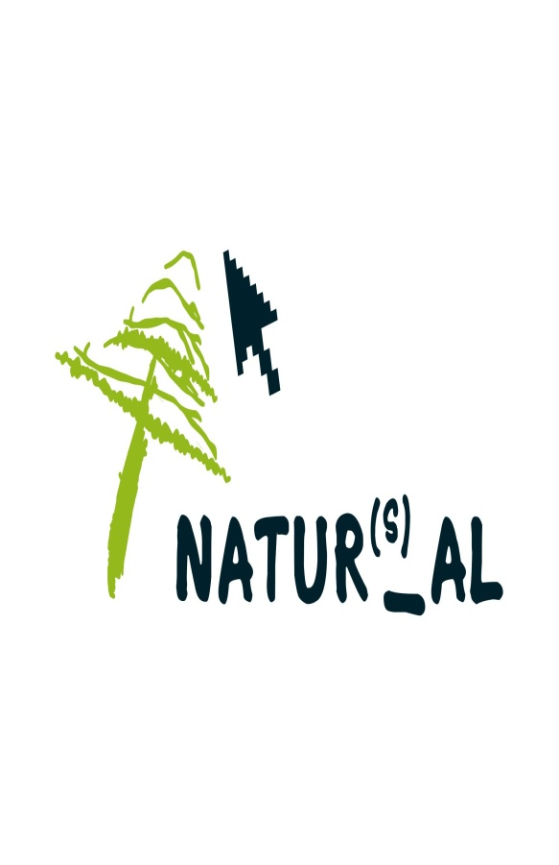
Name of Project: Involving Adult Learners in Natural Sciences to explore
Everyday world around us (2010-2012)

HP - MOS and its 6 European partners are engaged in a Project based on Natural Sciences that explores the world around us.

The main objective of the project is: to involve different institutions and organisations from different European countries to explore and share their expertises in Natural Sciences in an informal way.

The target groups of the project are adult learners from different European countries and backgrounds to engage in innovative ways of exploring Natural Sciences as a means of exploring the world.

The outcome of the project will contribute to an orientation of thinking with transfer of knowledge, creativity, innovation, development and awareness of Natural Sciences

THE PROJECT CONSIDERS NATUTAL SCIENCE IN FOUR MAIN AREAS:
(1).Exploring Natural Sciences in the context of intergenerational relations
(2). Exploring Natural Sciences in the context of ICT
(3). Exploring Natural Sciences in the context of involving Communities
(4). Exploring Natural Sciences in the context of Gender

The overarching outcomes of the European project are:
To share and exchange best practices, experiences and activities in each European organisation
To involve all community groups in natural science activities at European level
Captivate new learners, especially men using natural sciences subjects at European level
Enable information flow by sharing common activities and participating in transnational mobility
HP-MOS EUROPEAN PARTNERS INVOLVED:
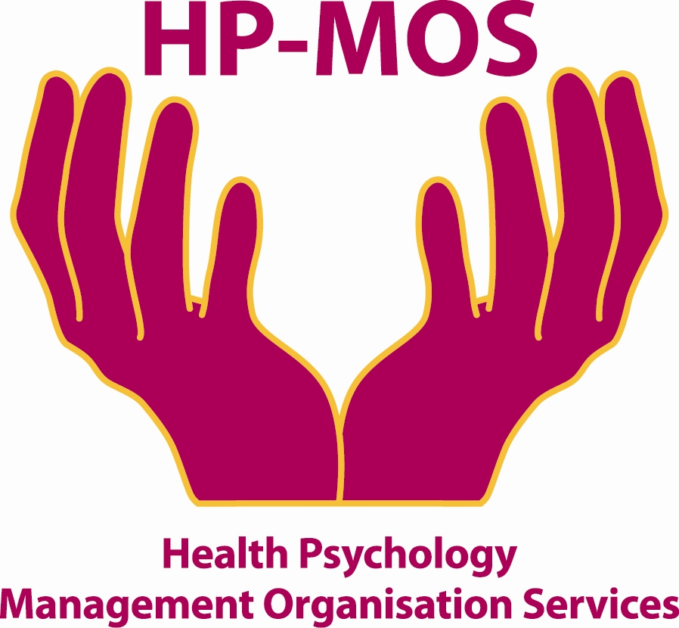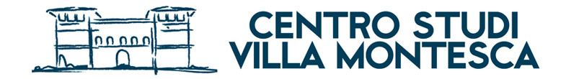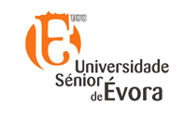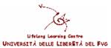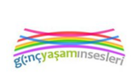
UK FINLAND ITALY PORTUGAL ITALY SPAIN TURKEY

FOR MORE INFORMATION, PLEASE CONTACT: MERCY MACLEAN.
E-MAIL: enquiries@hp-mos.org.uk
The project has been funded with support from the European Commission. This report reflects the views only of the author, and the Commission cannot be held responsible for any use which may be made of the information contained therein. Involving Adult Learners in Natural Sciences to explore Everyday world around us.
Project Agreement No: 2010-1-PT1-GRU06-05129

