HP-MOS European Partnership Project 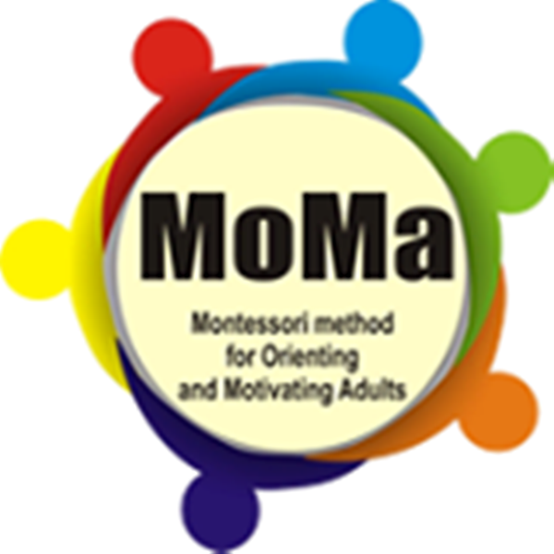
Project Title: Montessori Method for Orienting and Motivating Adults (MOMA) (2012-2014)
HP-MOS and its 6 European partners are engaged in a project that utilises the ideas of the Montessori method, such as: use of conversation; use of creativity and art; problem solving and critical and analytical thinking to involve adults in the creation of social and personal competences. The approach of the project's experimentation is based on the relationship between the personal and social background of adults and their educative environment, to address and to re-elaborate the setting of their educative space. The partnership approach intends to provide points of reference to teachers and operators in order to give an overview of how to adapt the Montessori educative method to the cultural dimension of adults with special social needs with different ethnic and cultural background.
THE OBJECTIVES OF THE PARTNERSHIP PROJECT: The outcome of the project is focused on creating a didactical framework containing the actualisation of the Montessori-Hallgarten method.
The bases of the outcome are:
• Participation of adults in singling out the setting of space and time as a way to adapt the space and time to the educational needs of adults.
• Setting a virtual space of learning for adults by taking into account their social networking by using an approach based on emotions to activate the creative side of adults.
• Considering the development of social skills and practising the principles of the pedagogy (social competences not imposed as given points of reference, but participating as principles of common views) education of adults transparent.
HP-MOS EUROPEAN PARTNERS INVOLVED:
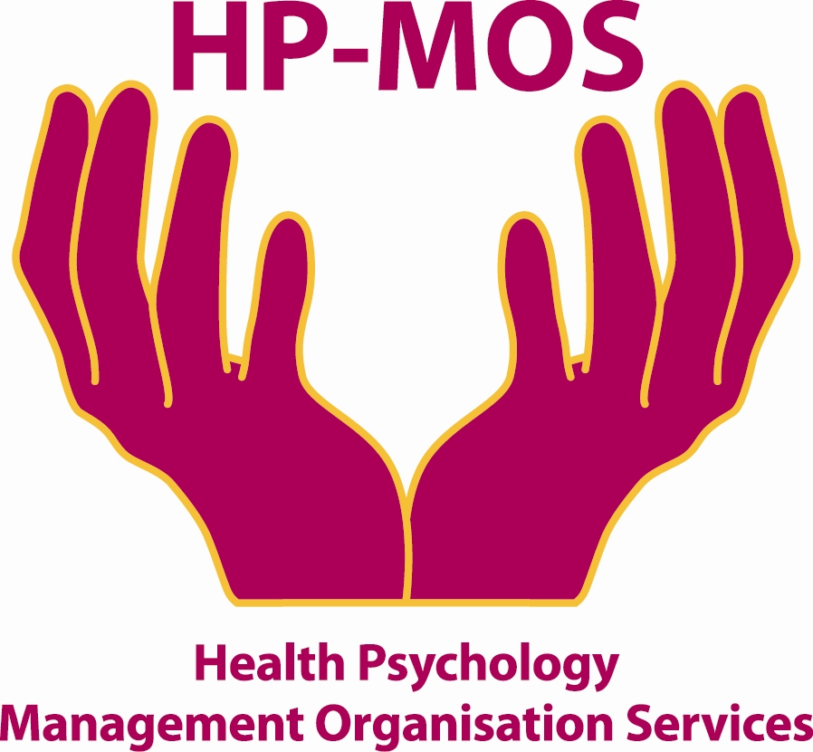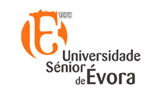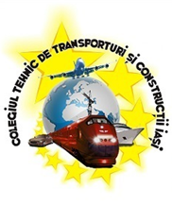
UK GERMANY ITALY LITHUANIA PORTUGAL ROMANIA SPAIN

FOR MORE INFORMATION, PLEASE CONTACT: MERCY MACLEAN.
E-MAIL: enquiries@hp-mos.org.uk
The project has been funded with support from the European Commission. This report reflects the views only of the author, and the Commission cannot be held responsible for any use which may be made of the information contained therein. Involving Montessori Method for Orienting and Motivating Adults (MOMA)
Project Agreement No: 527800-LLP-1-2012-1-IT-GRUNDTVIG-GMP

