HP-MOS European Partnership Project
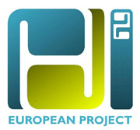
Name of Project: PhD²: Personal and human Development: Psychodrama to help the disadvantaged. (2008 - 2010).
HP - MOS and its 8 European partners are engaged in a European partnership project in social inclusion by means of Personal and human Development: Psychodrama to help the disadvantaged. (PhD). The main objective of the European partnership project is to study in depth the link between psychodrama, art therapy and social reinstatement of disadvantage people, to analyse the best practices in the field. It is widely accepted that, depending on the different causes of social exclusion, educational policies plays a strategic role as an essential tool for social cohesion. Psychodrama, in particular, is a method that, according to the different techniques adopted, becomes an effective tool for research, social reinstatement, therapeutic and educational pathways etc. Psychodrama resources are able to strengthen the social lives of people, to teach them adaptation strategies and to show them new ways in terms of emotional awareness and knowledge achievement.
The PhD² project intends to develop and experiment an integrated video-therapy and psychodrama method within a context in which a number of users with different degrees and levels of social disability, disadvantage and social exclusion can re-discover relationship and communication competences (psychodrama workshops) as well as acquiring specialised skills (audio/video production workshops) which can be useful for the integration or re-integration into a working context.
HP-MOS EUROPEAN PARTNERS INVOLVED:
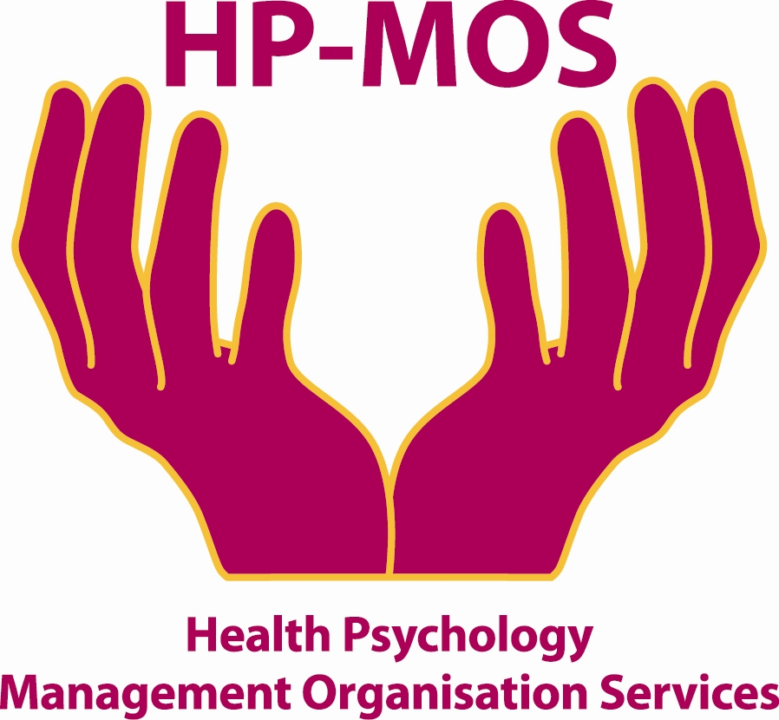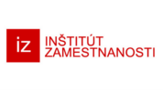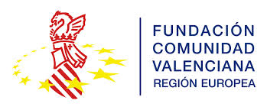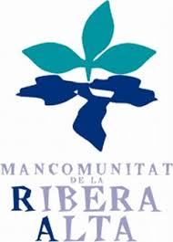
UK GREECE ITALY LITHUANIA ITALY SLOVAK REPUBLIC ITALY SPAIN SPAIN

FOR MORE INFORMATION, PLEASE CONTACT: MERCY MACLEAN
E-MAIL: enquiries@hp-mos.org.uk
The project has been funded with support from the European Commission. This report reflects the views only of the author, and the Commission cannot be held responsible for any use which may be made of the information contained therein. Project Title: PhD²: Personal and human Development: Psychodrama to help the disadvantaged
Project Agreement No: 2008-3457/001-001

