HP-MOS European Partnership Project 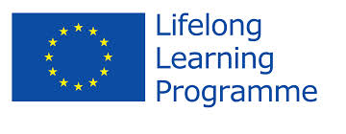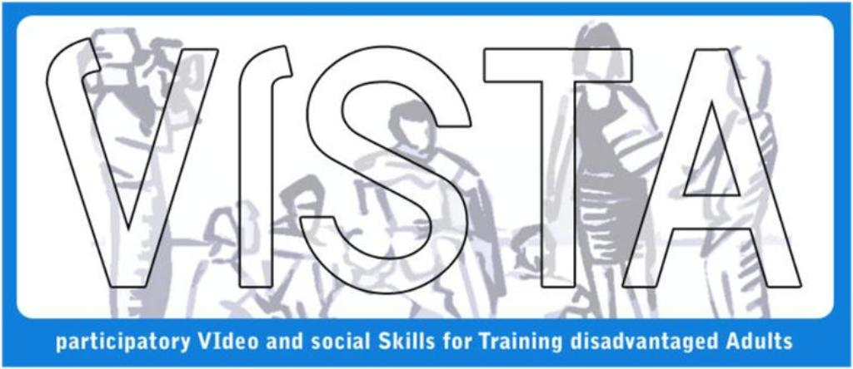Name of Project: The use of Participatory Video (PV) as a Methodology for Training Disadvantaged Adults’ Social Skills (2008-2010)
HP-MOS and its 6 European Partners are engaged in a project - The VISTA project adopts Participatory Video (PV) as a set of technique that involves a group or community in shaping and creating their own film. The idea behind this is that making a video is easy and accessible, and is a great way of bringing people together to explore issues, voice concerns or simply to be creative and tell stories. The process is very empowering, enabling a group or community to take action to solve their own problems and to communicate their needs and ideas to decision-makers and/or other groups and communities. As such, Participatory Video (PV) will serve as an effective tool to engage and mobilise marginalised and disadvantaged people and to help them implement their own forms of sustainable development based on local needs.
Participatory Video (PV) is used all over the world and has been applied in many different situations, from advocacy and enabling greater participation in development projects to providing a therapeutic and communicative environment for the mentally ill or disempowered. This involves the authorship of the group itself and it is carried out in a truly participative and democratic way. This quality of flexibility enables PV to be applied to many different situations.
HP-MOS EUROPEAN PARTNERS INVOLVED:
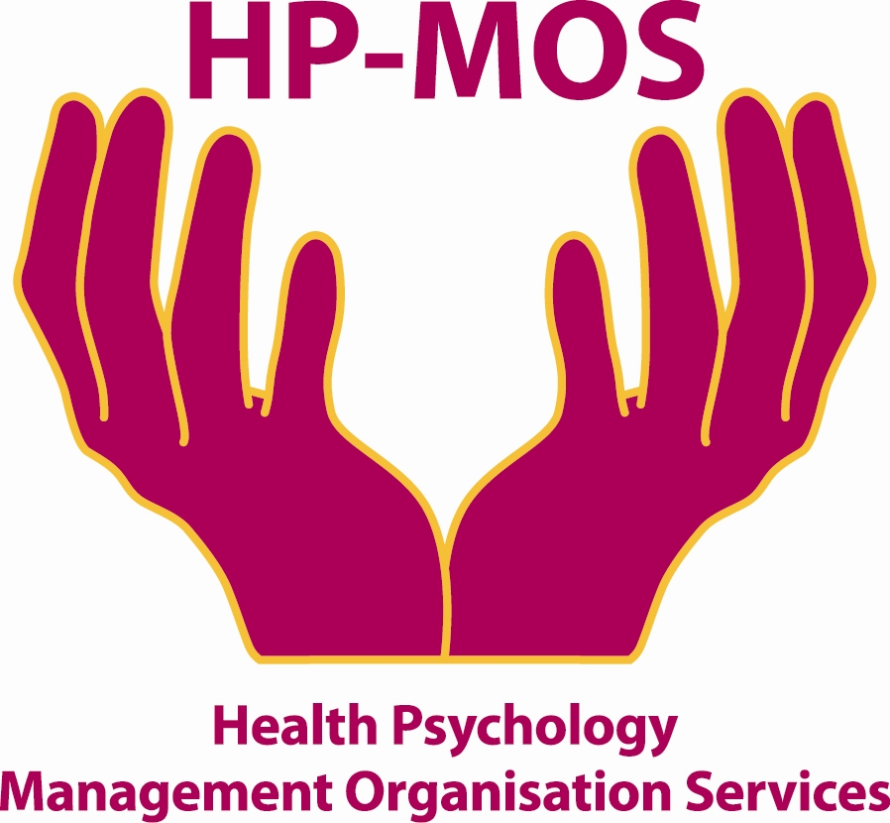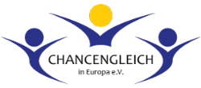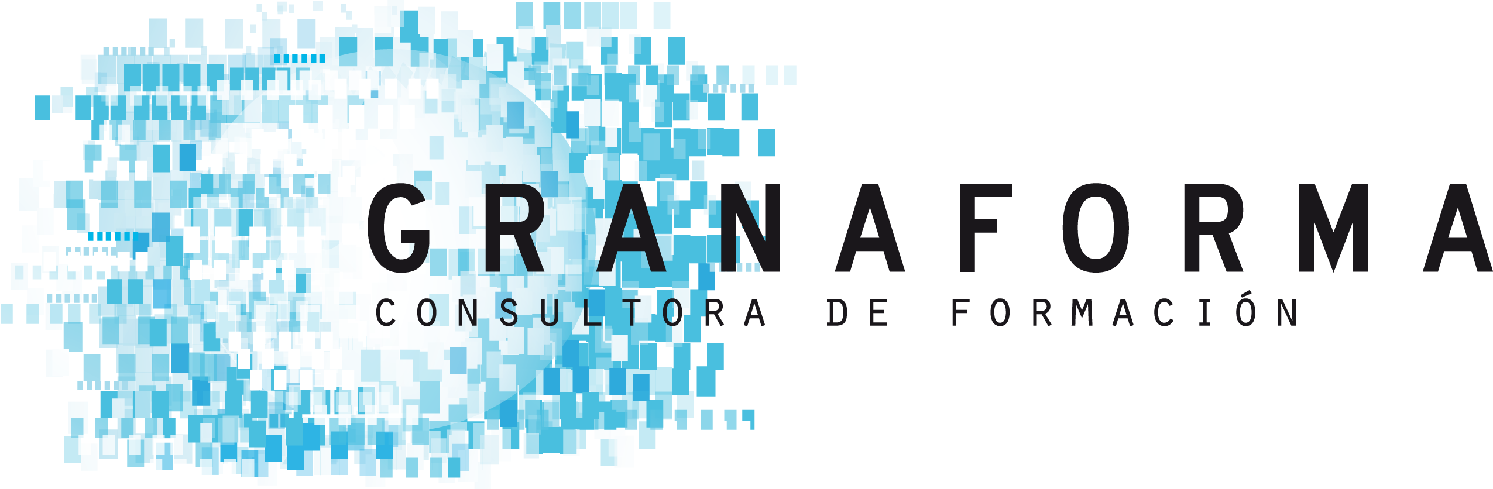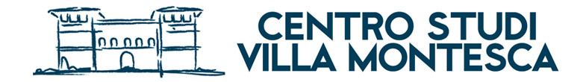
UK GERMANY GREECE SPAIN LITHUANIA SPAIN ITALY

FOR MORE INFORMATION, PLEASE CONTACT: MERCY MACLEAN.
E-MAIL: enquiries@hp-mos.org.uk
The project has been funded with support from the European Commission. This report reflects the views only of the author, and the Commission cannot be held responsible for any use which may be made of the information contained therein. Participatory Video and social Skills for Training disadvantaged Adults (V.I.S.T.A).
Project Agreement No:2011-3304/001- 001

