HP-MOS European Partnership Project 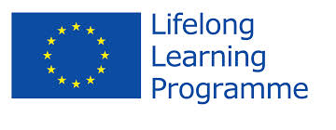

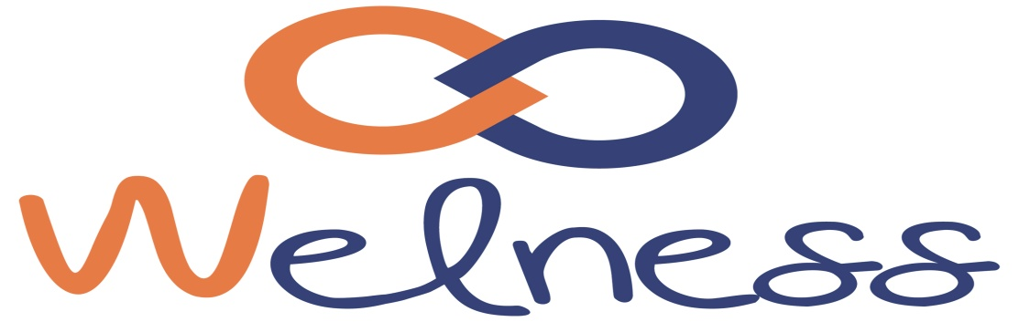

Name of Project: WELLNESS -Skills for True Wellbeing (2012-2014)
HP-MOS European partnership project - WELLNESS -Skills for True Wellbeing - aims to improve the content and delivery of adult education through the provision of skills that enhance wellbeing of professionals and learners. The project is a collaboration between 7 different European organisations involved in adult education from 6 different European countries. The project is designed to implement a cross-national needs analysis to facilitate training tools and courses that allow educators to monitor their levels of wellbeing and to apply self-regulation strategies in order to achieve satisfying levels of wellness.

Our approach is based on developing sets of easily applicable skills that help individuals and organisations to increase their levels of wellbeing. A great deal will be given to raising awareness of the importance of wellbeing and promoting easily accessible free materials for professionals and learners. This project emphasises the importance of lifelong learning that enhances the quality of life and overall wellbeing throughout the whole lifespan. The project aims to contribute to providing measurable indicators of wellbeing across six European Countries.
HP-MOS EUROPEAN PARTNERS INVOLVED:
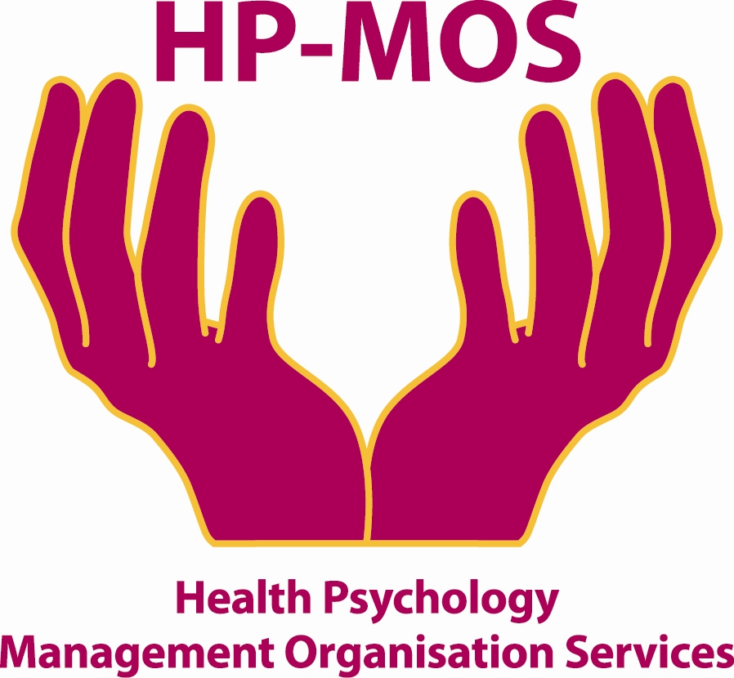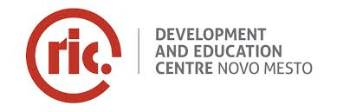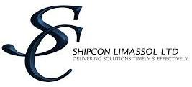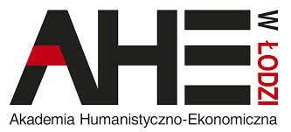
UK ROMANIA SLOVENIA CYPRUS ITALY ITALY POLAND
(PROMIMPRESA) (FORMAZIONE)

FOR MORE INFORMATION, PLEASE CONTACT: MERCY MACLEAN
E-MAIL: enquiries@hp-mos.org.uk
The project has been funded with support from the European Commission. This report reflects the views only of the author, and the Commission cannot be held responsible for any use which may be made of the information contained therein. "Skills for True Wellbeing" - Wellness.
Project Agreement No: 527797-LLP-1-2012-1-RO-GRUNDTVIG-GMP

