HP-MOS European Partnership Project
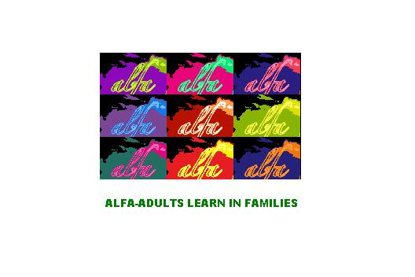
HP - MOS and its 6 European Partners are engaged in Transnational Mobility project entitled: Adults Learn in Families (ALFA): EU Lifelong Learning Programme (2009-2011).

•The Grundtvig Partnership will address the UK priority of assisting different adult Learners from vulnerable social groups and from marginal social contexts, in particular older people and those who have left education without basic qualifications, in order to give them alternative opportunities to access adult education across Europe.

•This priority will be addressed by studying the relationship between generations and develop a path to promote joint parents/children learning method based on different cultural approaches. Open source tools such as ICT-based educational content, services and practices would be used as strategic resources to encourage de-personalisation and the giving up of traditional roles in order to minimise generational conflicts.

Actions for the project include:

•Mobilities to be carried out to partner institutions approved for funding in the same Partnership and the preparations needed to plan the exchanges
•Mobilities to be undertaken by staff and learners of the participating organisations
•Grundtvig Learning Partnerships focusing on themes of mutual interest to participating organisations
•Multilnational projects for improving adult education systems through the development and transfer of innovation and good practice

Adults Learn in families (ALFA ) is funded under the Grundtvig Partnership Program of the EU Lifelong Learning Programme. Project agreement number: 2009-1-IT2-GRU06-06451 8
HP-MOS EUROPEAN PARTNERS INVOLVED:
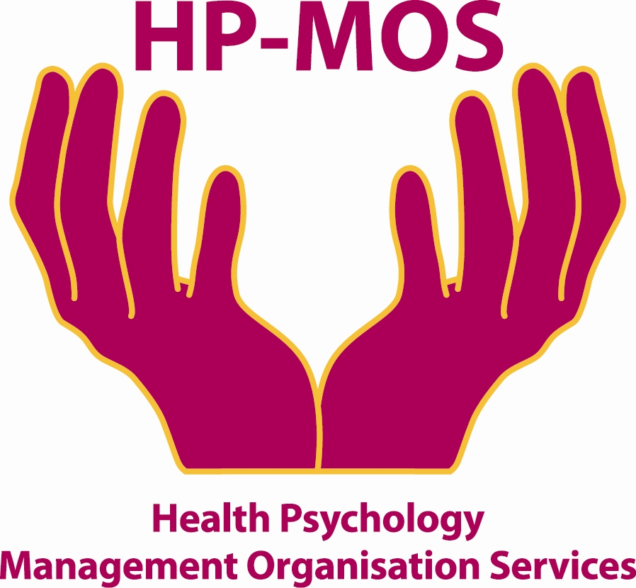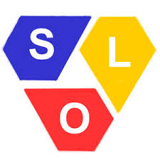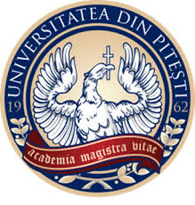
UK FINLAND GERMANY POLAND ROMANIA THE NETHERLANDS GERMANY

FOR MORE INFORMATION, PLEASE CONTACT: MERCY MACLEAN.
E-MAIL: enquiries@hp-mos.org.uk

The project has been funded with support from the European Commission. This report reflects the views only of the author, and the Commission cannot be held responsible for any use which may be made of the information contained therein. Involving Adults Learn in families (ALFA )
Project Agreement No: 2009-1-IT2-GRU06-06451 8

