HP-MOS European Partnership Project (2017-2019)

Title of Project: FEMME - Fostering the Exchange of practices to empower mumpreneurship in Europe

HP-MOS and its 7 European partners from Portugal (project coordinator), Italy, Romania, Bulgaria, Spain, Hungary and Greece are engaged in a European partnership project: FEMME - Fostering the Exchange of practices to empower mumpreneurship in Europe.

The Project examines Mumpreneurs - a concept that incorporates Maternity and Entrepreneurship, which involves women who, after becoming mothers decides to create their own business. In Europe, informal groups of women who feel the need to join their peers to exchange ideas, share knowledge and expand their business are mostly developing that movement.

THE OVERALL OBJECTIVES OF THEPROJECT ARE:
-To empower trainers/adult educators on mumpreneurship;
-To empower mumpreneurs;
-To know the state of the art of mumpreneurship in the partnership countries;
-To exchange best practices on mumpreneurship initiatives;
-Dissiminate information on mumpreneurship by establishing the basis for an European Network on Mumpreneurship;
-To ensure economical/social gender equality

THE OUTCOMES OF THE PROJECT AREE AS FOLLOWS:
1. Report on the state-of-the-art of European Mumpreneurship
2. Guide on European best practices on Mumpreneurship
3. Guide with experiences/recommendations for Trainers/Adult Educators on Mumpreneurship initiatives
4. Guide for Mumpreneurs
5. Leaflets, Web and Facebook page

TARGET GROUP
- Incubators/trainers/adult educators
- Mumpreneurs

The Partnerships are as follows:

AML– Associação Mãe Limão,.  Project Co-ordinator | 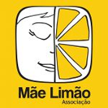 | Portugal
Health Psychology Management Organisation Services (HP-MOS) |  | United Kingdom
Asociatia Nationala A Femeilor Din Mediul Rural |  | Romania
Consorzio Social Lab Societa Cooperativa Sociale |  | Italy
Institute of Entrepreneurship Development (iED), |  | Greece
Business Incubator - Gotse Delchev | 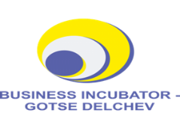 | Bulgaria
CÁMARA Oficial De Comercio, Industria Y Servicios De Badajoz | 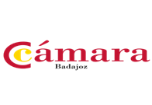 | Spain
PECS-Baranyai Kereskedelmi Es Iparkamara | 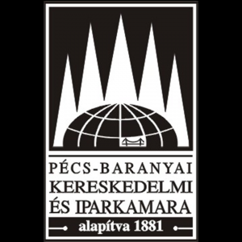 | Hungary

For fuhrer information please conatct: mercy.maclean@hp-mos.org.uk (UK Lead). The project has been funded with support from the European Commission. This information reflects the views only of the author, and the Commission cannot be held responsible for any use which may be made of the information contained therein.

